Project Title : Employee Rewards And Recognition
Business Requirements:
- Functional Requriements
  - Employee Data Object Management
    - Creation of custom Object to store employee records
    - It includes Fields like Employee Name, ID, Attendance, Performance etc.
  - Top Performer Identification
    - The System has to Identify the top 4-5 employees who are at the top based on the criteria.
  - Automated Reward Evaluation
    - Rewards Should be awarded to the employee based on their performance automatically for every 6 months.
  - Email Notification
    - After the evaluation of the reward the email has to be sent to the selected top performers which contain reward type.
- Non – Functional Requirements
  - Security
    - Only authorized admins should be able to modify and access the reward assignment.
    - Use Profiles to control access.
  - Scalability
    - It must be capable of handling a growing number of employee records.
Step 1: Creating App
Switch to Salesforce Classic
Setup > Build > Create > Apps > Quick Start
Create Employee Recognition Tracker app
Add the Following tabs to Selected Tabs
- Home
- Employees
- Dashboards
- Reports
Default landing tab : Dashboard
Save
Switch to Lightning
Setup > App Manager > Apps > Employee Recognition Tracker > Edit
Check Show in Lightning
Save
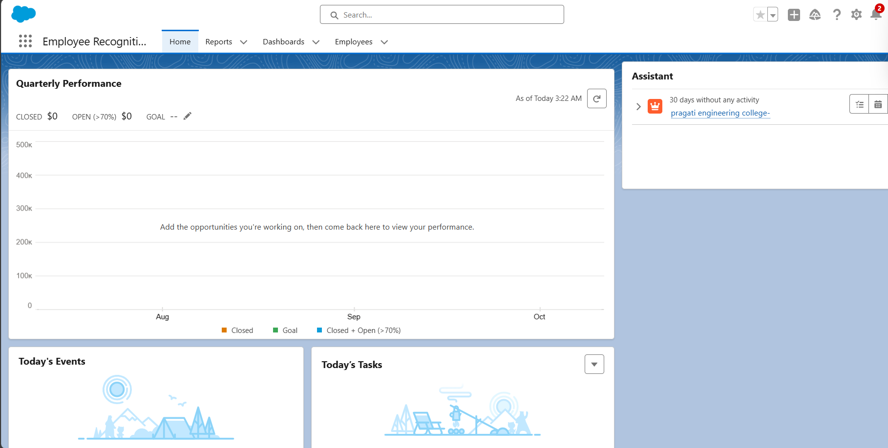

Step 2 : Profiles Creation
Create profile
Setup > Quick Find > Profiles
Create New Profile
Existing Profile : Standard user
Profile Name : HR Manager
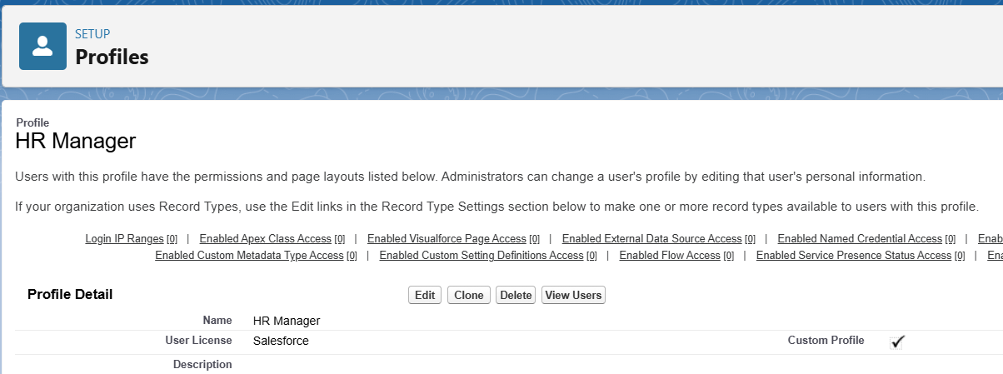
Create user
Create new user and assign Profile HR Manager

Step 3 : Create Object and Add fields
Setup → Object Manager → Create → Custom Object
- Fill in Label & Plural Label
- Enable all optional features, search status, and object creation options
- Click Save
Setup → Object Manager → Create → Custom Object → Fill Label & Plural Label → Click all Optional Features, Search Status & Object Creation Options and then Save
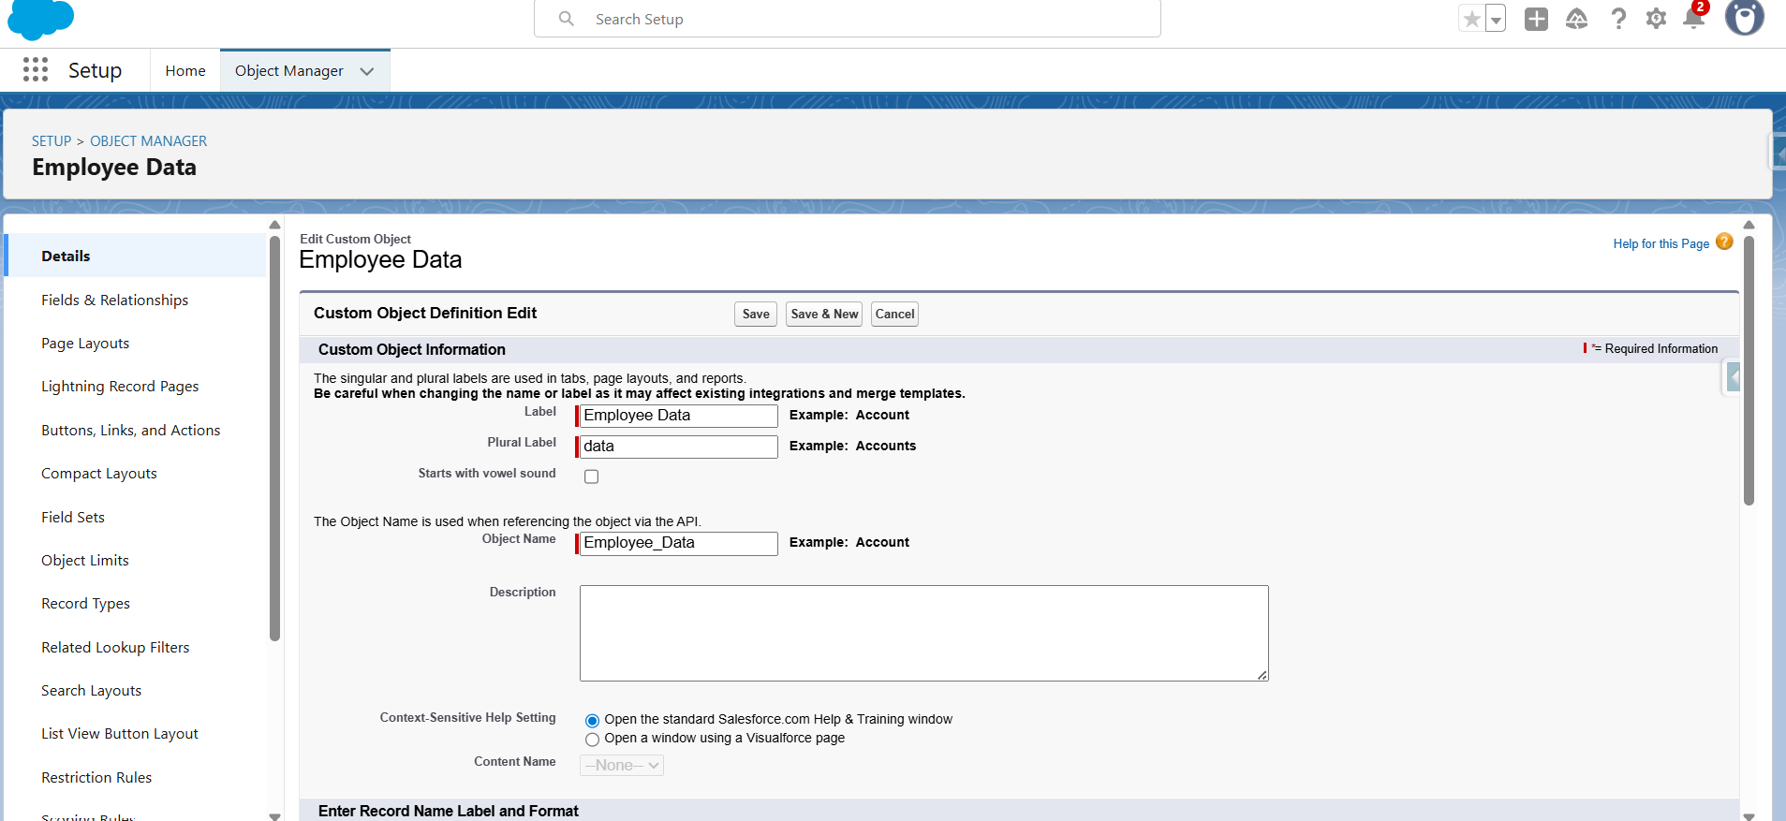
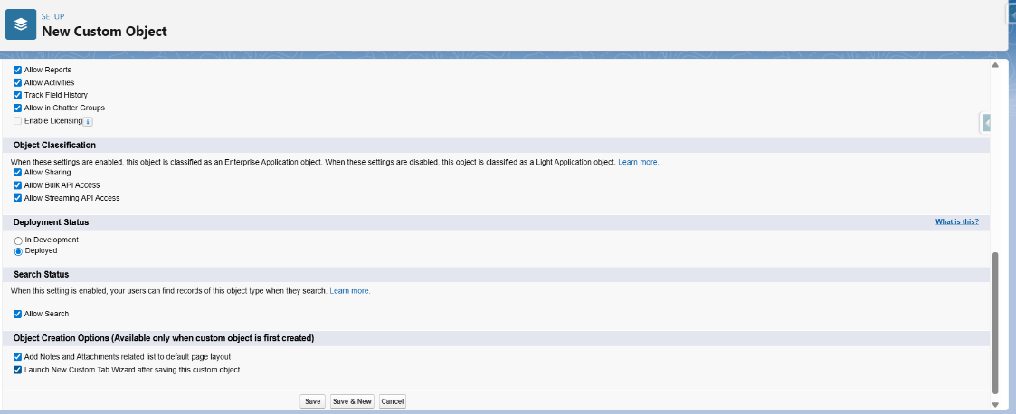

Fields and relationships----->New----->datatype related to field required---->next
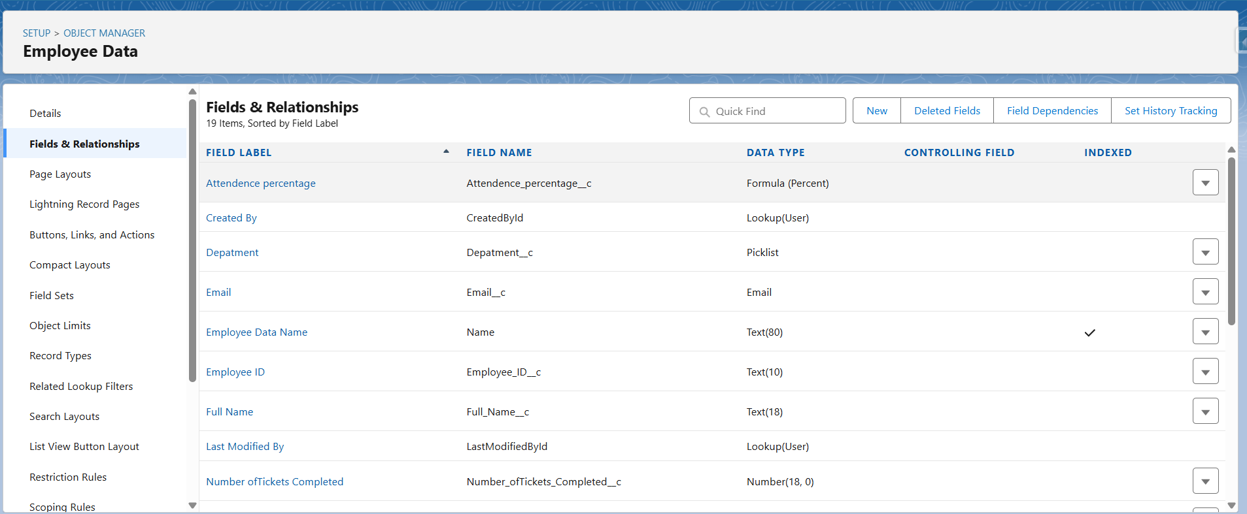
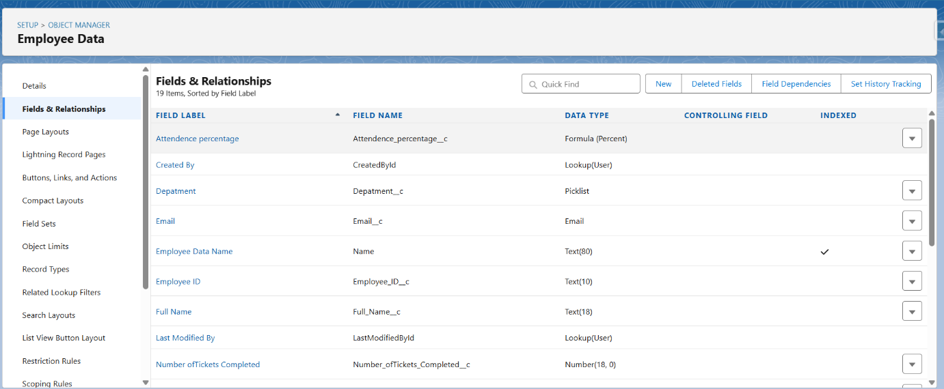
Step 3 : Flows
Creating Schedule Trigger Flow
Setup 🡪 quick find 🡪 flows 🡪 new flow 🡪 schedule trigger flow
Start Date : Jan
Time : 12:00 AM
Frequency : Once
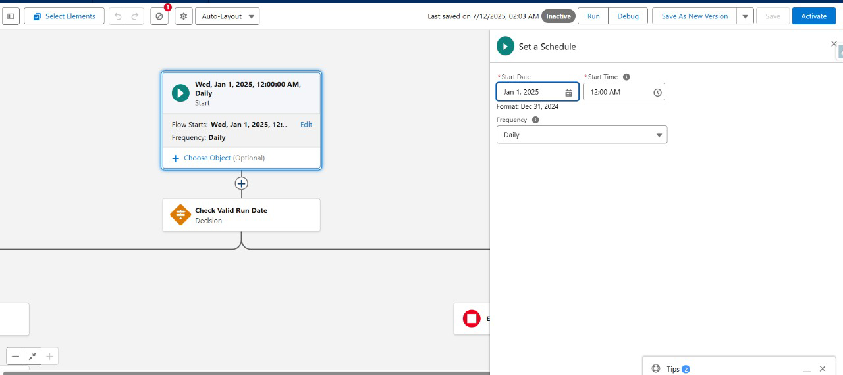

Create new resource
Resource Type : Formula
API_Name : Is_Jan
Data Type : Boolean
Formula : Month(TODAY()) = 1 && DAY(TODAY()) = 1
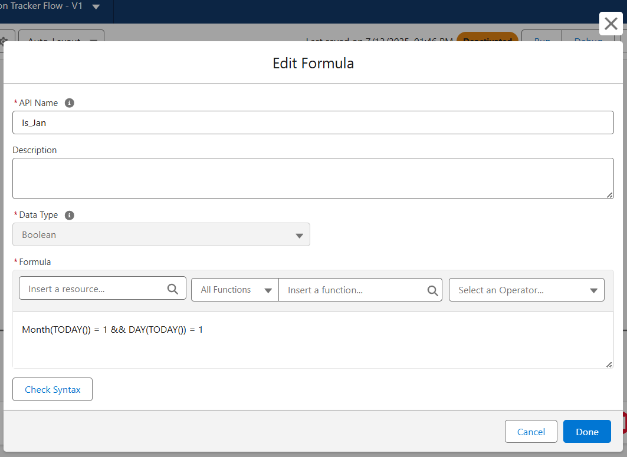

Same for Is_July And for Is_Today In Place of Formula Enter TRUE

Click on Plus After Start and Select Decision
Check Valid Run Date
Label : Check Valid Run Date
API Name : Auto Filled
Out Come Details :
Label : Is_Jan or July
Condition Requirements to Execute Outcome : Custom Condition Logic Is Met
Condition Logic : 1 OR 2 OR 3
Resource : Is_Jan
Operator : Equals
Value : True

Same for is_july and IS_today
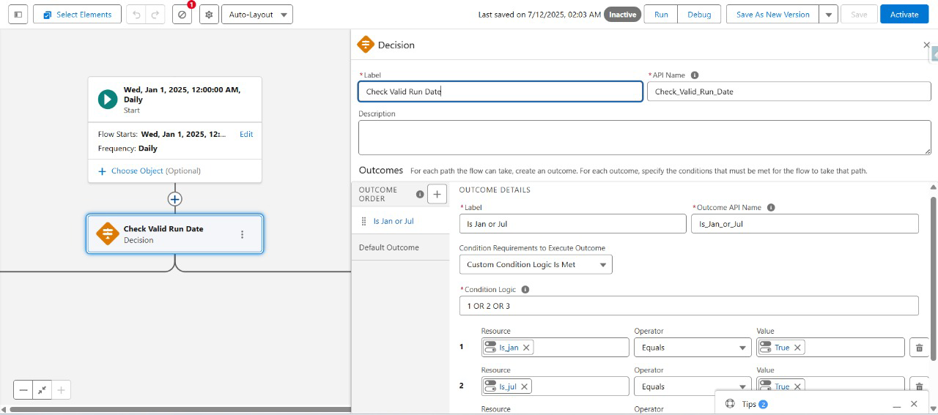

Click on plus afer Is_Jan or July

Get Qualified Employees
Label : Get Qualified Employees
Object : Employee Data
Filter Conditions : All Conditions Are Met
- Field : Attendance Percentage
Operator : Greater Than
Value : 90
- Field : Performance Based Score
Operator : Greater Than
Value : 0.9
- Field : Task Completion Percentage
Operator : Greater Than
Value : 90
Sorted Order: Descending
How Many Records to Store: All, Records Up to a Specified Limit
Max Number : 4
How to Store Record Data : Automatically Store All Fields

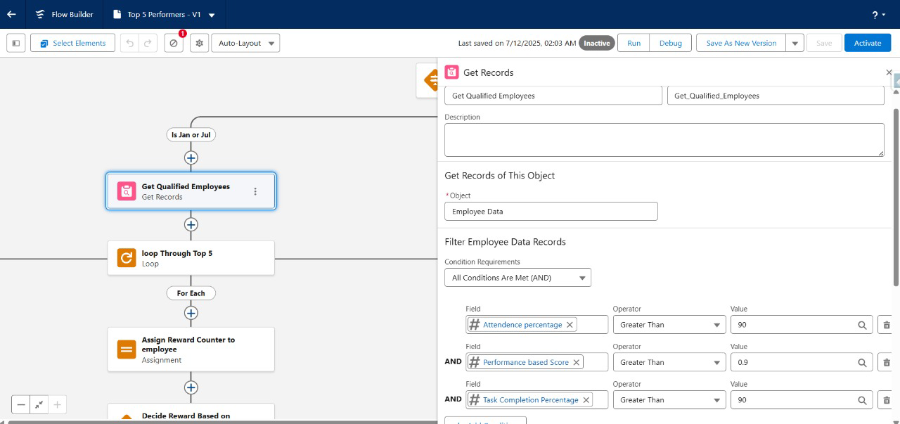
Click on Plus Below Get Qualified Employee and Select Loop

Loop through top 5
Label : Loop Through Top 5
Collection Variable : Data from qualified Employee
Direction : First item to Last item

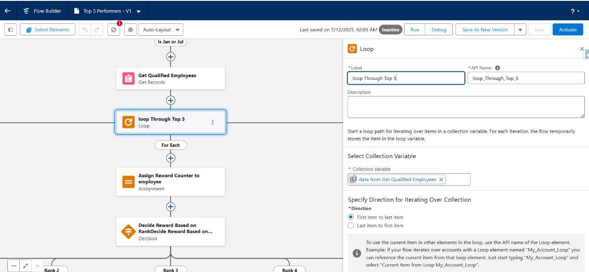
Click on plus below the for each and Click Assignment

Assign Reward Counter To Employee
Label : Assign Reward Counter to Employee
- Variable : Loop through top 5 > Top 5 Performer
Operator : Equals
Value : True
- Variable : Loop Through Top 5 > Rank
Operator : Equals
Value : Reward Counter
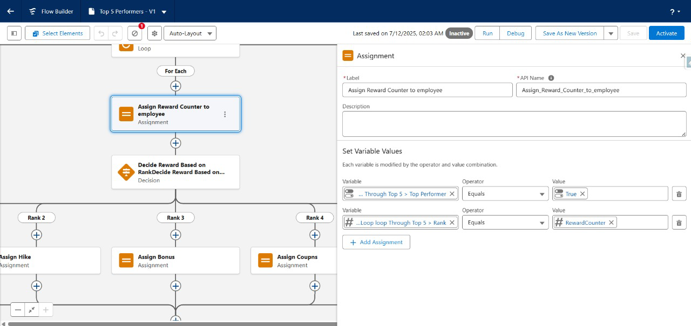

Click plus after assign reward counter to employee and click on decision

Decide reward based on rank
Label : Decide Reward Based on Rank
Out come Details :
Label : Rank 1
Resource : Reward Counter
Operator : equals
Value : 1
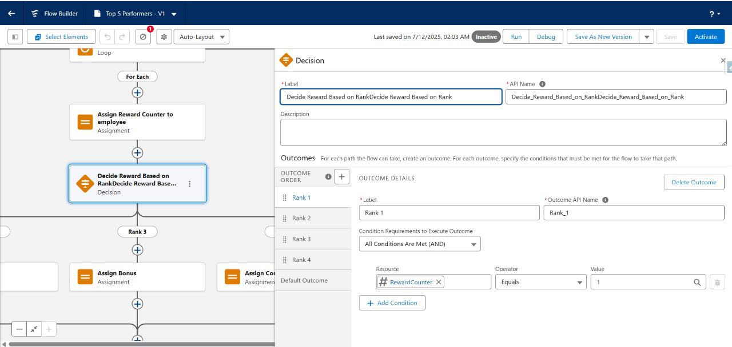

Do same for Rank 2, 3, 4 and click on plus symbol after that and click assignment

Label : Vacation
Set Variable Values >
Variable : Loop Through Top 5 > Rank
Operator : Equals
Value : Vacation
Do the same and assign rewards for each path of Ranks 1, 2, 3, 4
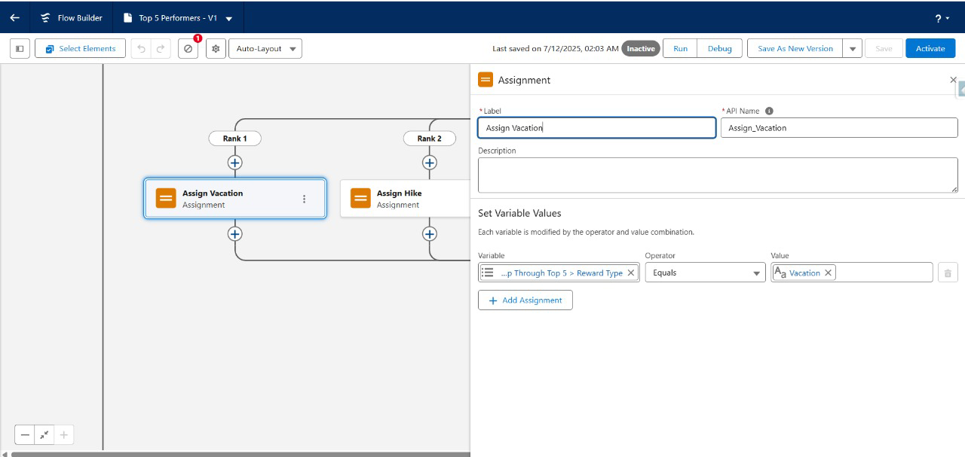
Rank 1 : vacation
Rank 2 : Hike
Rank 3 : Bonus
Rank 4 : Coupons
Increment Reward Counter
Label : Increment Reward Counter
Variable : Reward Counter
Operator : And
Value : 1

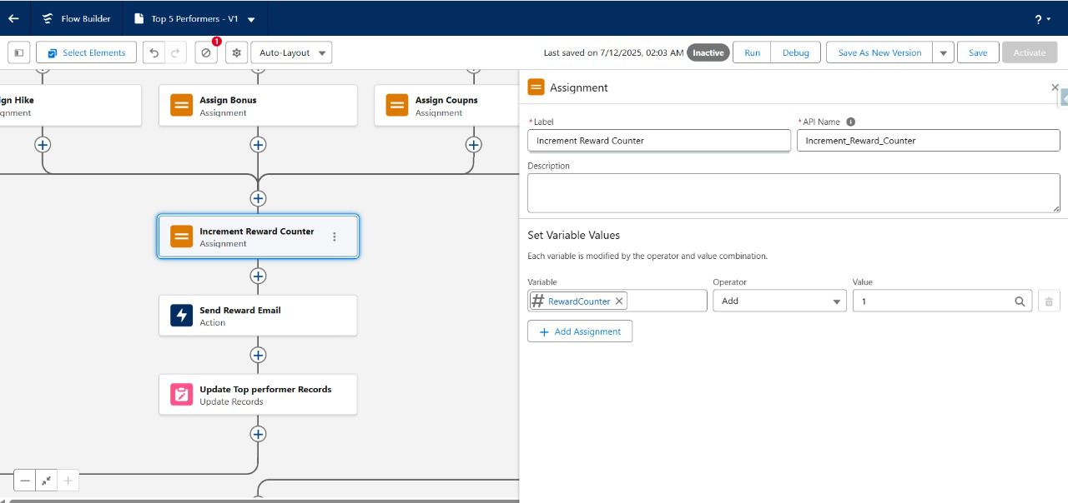
Click plus after increment reward counter and select action

Send Reward Email
Label : Send reward Email
Recipient Address list:
CC Recipient Address List:
Sender Type: CurrentUser
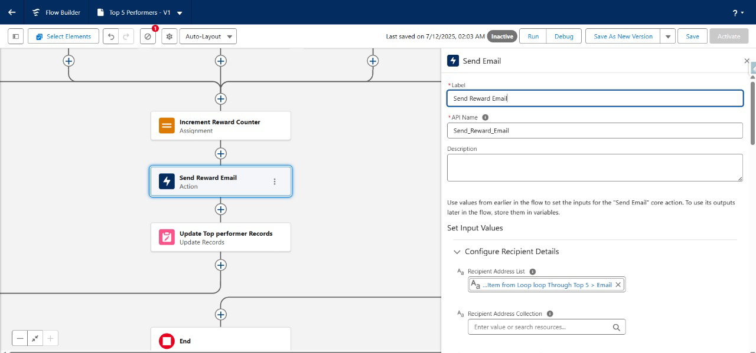

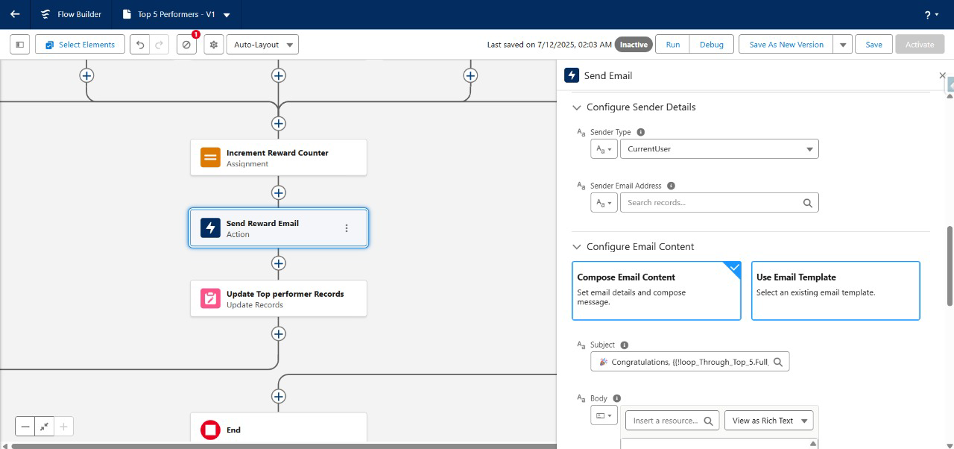

Step 4 : Reports & Dashboards

Creating Reports
For the sample data we have used a .csv file having the fields required.

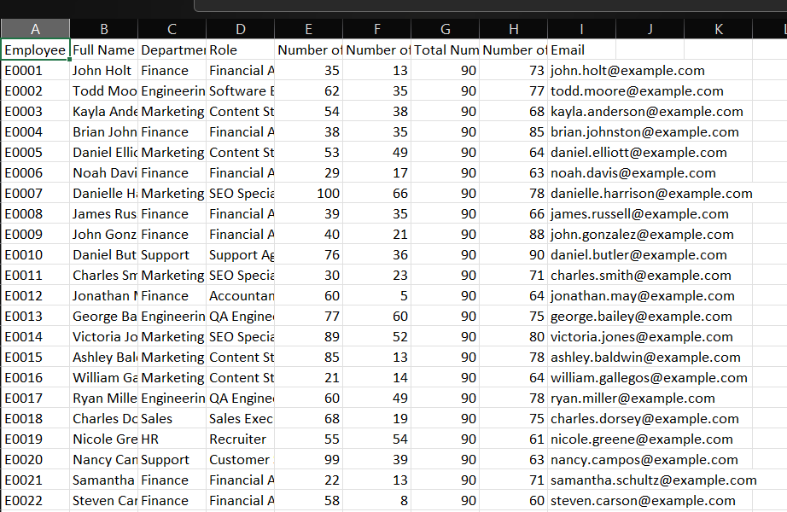
Import the data using Salesforce Inspector
Object :Employee Data
Data : Paste all the fields into the area
Map all the fields
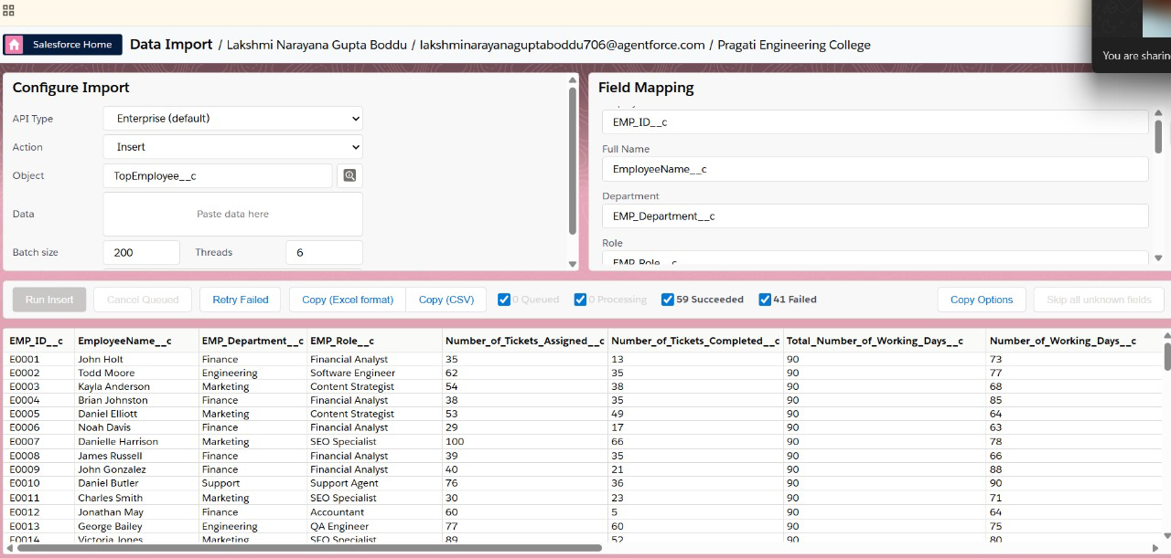
Run Insert
Reports Creation for dashboards
App Launcher > Reports
Create New Folder
Label : Employee Recognition Reports
Click New Report
Select Employee Objects
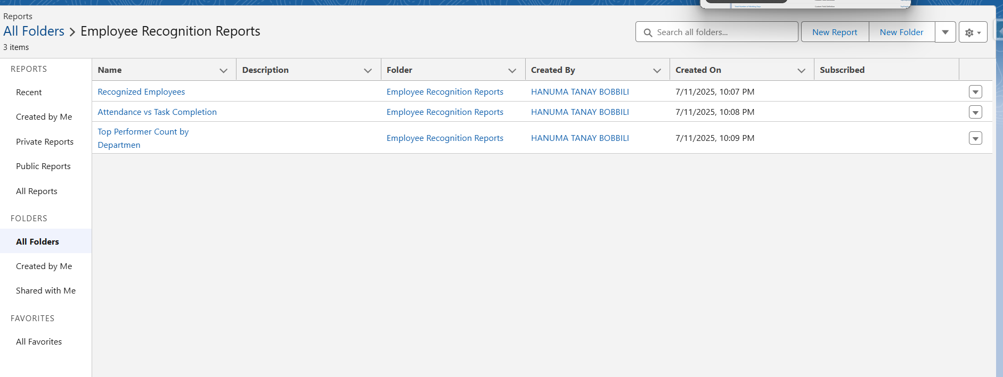
Create These 3 Reports
Recognized Employees
Columns : Employeename, Department, Performance Score, Reward Type, Rank
Filters :
- Attendance Percentage > 90
- Performance Score > 0.9
- Tasks Completion percentage > 90
- Top Performer = true
Save
- In the same way Create the other 2 reports
- Top Performer Count by Department
- Attendance Vs Task Completion
Dashboard Creation
New Folder: Employee Recognition Dashboard
Add 3 Reports
Adjust the positions
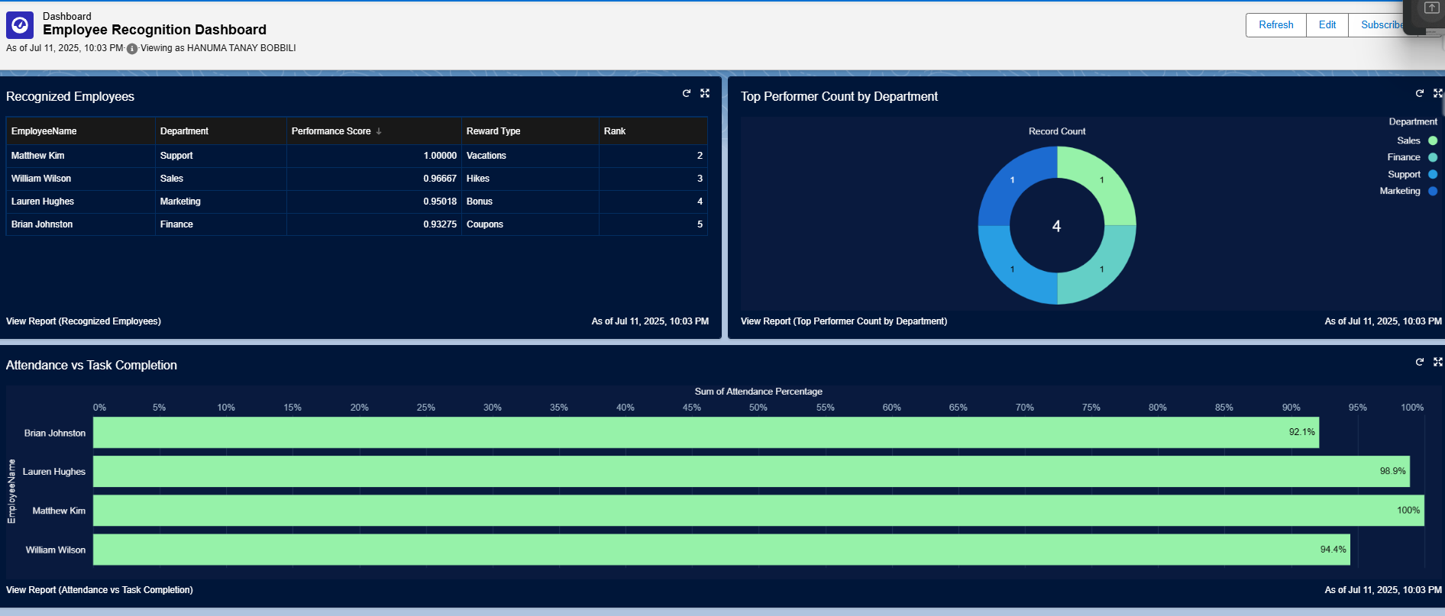
Click Save.

Step 6: Dashboard Access Configuration
Configuring Dashboard Access
Select Drodown aside Employee Recognition folder in Dashboards where Dashboard is Present
And click share
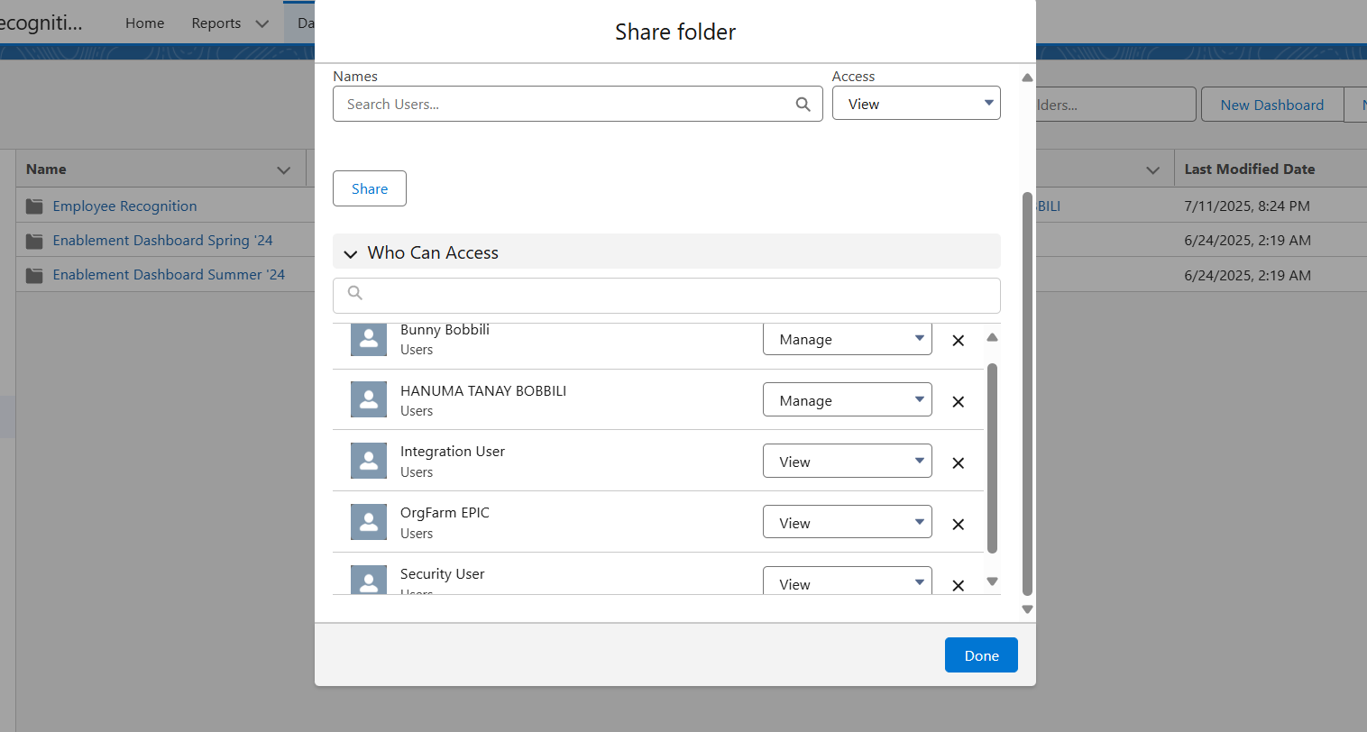
Select Users Under Share With
Under Names
Select each user and edit access and click share
User (System Administrator) - Manage Access
User (HR Manager) – Manage Access
Rest of Users – View Access
Done

Tools & Features Used
Tool / Feature | Purpose
Object Manager | Created custom objects and fields
Profiles | Controlled user access using custom profiles
Flows (Process Automation) | Automated report generation and sent reward emails to top performers
Reports & Dashboards | Visualized performance data such as top performers

Testing Results
Test Case ID | Test Description | Input / Setup | Expected Result | Actual Result | Status
TC_01 | Custom Object & Field Creation | Employee data with required fields | All fields created and visible in the object | Successfully created all fields | Passed
TC_02 | Filter Qualified Employees | Records with performance criteria | Only eligible employees are fetched | Correct eligible list returned | Passed
TC_03 | Email Sent to Winners | Flow triggered after reward assignment | Emails sent to top 4 performers | All 4 emails successfully received | Passed

Test Environment
- Salesforce Org Type: Developer Edition
- Data Used: 50 sample records, 5 high performers
- Test Tools: Flow Debug, Email Log, Object Record View

